First pass of sections thanks to ChatGPT!
1. Game Overview
- Game Title
  - Life From Space
- Genre (e.g., strategy, party, RPG, etc.)
  - Worker Placement
  - Resource Management
    - Many Similar Elements to “Lords of Waterdeep”
      - https://www.youtube.com/watch?v=D7DvEIfrP84
  - Collaborative Multiplayer for classroom version
  - More Collaborative / Competitive for “full” version
- Player Count & Recommended Age
  - 4-6 for classroom use
  - Age range
    - Variants of gameplay to match learning outcomes at different school levels with matching age requirements.
- Game Duration
  - 30 minutes for base game (playable during a class session)
  - 60 minutes for fuller game
- Elevator Pitch (1-2 sentence summary)
  - A race of lonely aliens travels the universe seeding life.
    - Think the Monolith in 2001.
  - Travel to various stages / locations within the Universe/stellar life cycle to seed the building blocks of life on Earth.
- Unique Selling Points
  - An Astrophysical chemistry-based game designed by Astrophysicists!
  - Modes of play: Educational over full Euro-game.
2. Game Components
- List of Components (cards, tokens, dice, board, etc.)
  - Game Board
  - Molecule Cards
  - Stellar Event Cards
  - C60 Die
  - Spaceships
  - Atom / small molecule resource tokens
    - H,C,N,O,H₂O
- Component Descriptions & Specifications
  - Game Board [[add rough sketch of board]]
    - A large, beautiful board, with a “space” design background sectioned into zones (5-6). Arrows connecting main zones to show the “life” cycle. You start in the centre of the board in the interstellar medium zone.
    - Zones: Each zone has a slot/ slots for player Spaceships to move to.
      - Big Bang
        - The Big Bang is a zone where you produce resources and your resources that you're producing in The Big Bang are primarily hydrogen
        - Centre left.
      - Planetary Nebula
        - And the dense regions
        - Where the molecules are created
      - Hot Zone
      - Star
        - On the right, the star is also producing resources and that's primarily producing carbon, oxygen, and nitrogen.
      - Supernova
        - At the top. Also, a resource-producing place, but that's going to produce more complex resources like iron and things.
      - Interstellar Media
        - Central Zone made up of little squares/hexagons faintly marked.
        - Connects to the other zones like a Cluedo board
        - Hop through here to access the other zones
      - Earth
        - The bottom left corner 1/4 image of Earth + James Webb Telescope. “Win” location of the game.
    - Rectangles
      - Locations for placing Molecule cards, like Lords of Water Deep Buildings. Around the board.
      - Locations for “Event” card deck and its discard pile.
  - Molecule Cards
    - Each card has a description of a molecule that we want to collect, and it can be marked on the zone. Each placed in locations around the board.
      - Smaller ones at the top
      - Larger ones are later
        - Chemicals like sugars and amino acids
    - Initially, cards are “greyed out” until claimed.
    - Turn over to reveal the full colour version.
    - Borrowing from Catan each card shows the resources required to construct it/activate the card. Instead of 2 wood and a stone.
    - Here you’ll need 3 carbons, 2 hydrogens and an oxygen.
    - 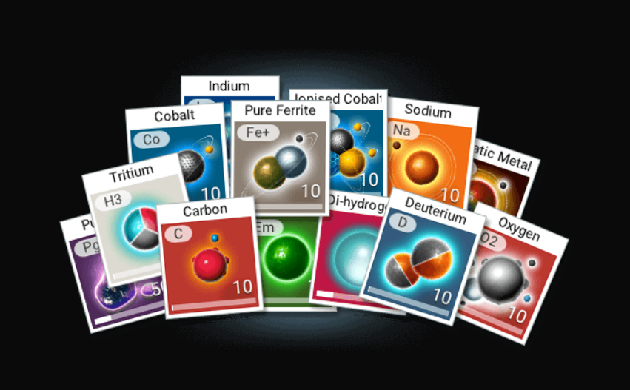
    - Possible design example from No Man’s Sky
  - Event Cards
    - Linked to astrophysical events
    - Affect the resources held by each player to prevent hoarding
    - Flavour text for “Fun Facts” 😉
  - Spaceships
    - Rocket Meeples to show location “occupied” by each player
  - Atom / small molecule resource tokens
    - Possible reuse of our Chemonioes
- Art & Graphic Design Considerations
  - The board needs to be “BEAUTIFUL!”
    - Zones which we can be illustrated on the board using James Webb images and really beautiful master images.
    - Question of rights issues for these images?
3. Gameplay & Mechanics
- Core Gameplay Loop
  - Movement of players to various areas on the board, each are associated with an astrophysical location and where the players obtain the resources pertaining to that location
  - Players will use resources (aka atoms and molecules) to build increasingly complex molecules, via the Molecule Cards, with the first player to produce them, turn card over to coloured side, getting points but the resource then becomes available to all other players
    - Similar concept to buildings in Lords of Water Deep
      - Possibly similar mechanic of that player getting a bonus for others using “their” resource
    - Eventually building up to other molecules with more unusual elements and Amino Acids, which can then be sent to Earth to initiate life.
      - This is the win condition.
- Board Locations: [[List all locations and resources to be collected from them and actions that can be carried out there]]
  - Supernova
    - Production of higher atomic weight species and more complex resources: e.g. iron
    - Not in play to begin with, as most simpler molecules won’t require it.
      - A player has to move to this location on the board to collect these more complex/difficult elements
      - Possibly connected to an Event Card
  - Earth
    - Deposit ingredients for creating life here for large bonuses
    - Difficulty could be set by having stages for this
      - First, get Earth sufficiently wet by depositing water, then move onto the early stages of life
        - amino acids, sugars, etc
    - Earth has a track like an extended Molecule card
      - Water x times, sugars, amnios etc
      - Marker moves up this as the play deposits the ingredients.
      - Player to place the last stage gets a bonus.
  - Starbase
    - A touch of sci-fi, location to collect molecule cards.
    - Essentially go back to base to select your next mission(s).
- Molecule Cards
  - [[Repeat from Above]] Each card has a description of a molecule that we want to collect, and it can be marked on the zone. Each placed in locations around the board.
    - Smaller ones at the top
    - Larger ones are later
      - Chemicals like sugars and amino acids
  - Initially, cards are “greyed out” until claimed.
  - Turn over to reveal the full colour version.
  - Borrowing from Catan, each card shows the resources required to construct it/activate the card. Instead of 2 wood and a stone.
    - Here you’ll need 3 carbons, 2 hydrogens and an oxygen.
  - These could be held in the hand of the player until they have sufficient resources to create them and then played to the board
  - Player gets points for this, but the molecule is now at a location on the board and can be used as though they are a resource the player has during the Reaction Phase for any player at that location.
  - C60
    - Really needs to be a near-end game molecule card!
    - An interesting feature to match science is that if this is “destroyed” it becomes a range of new resources
    - Essentially making a positive out of one of the negative events
    - C60 protects your interstellar medium.
    - So you can use the game mechanics to build up the science and why we think C60 in the interstellar medium is important for life, for example.

- Event Cards
  - Astrophysical events which affect the resources held by players.
    - Or could be held by players to “attack” other players
    - Difference between the Educational and Entertainment versions.
  - Strong set of mechanics for adding additional “science” to the game.
    - This can have positive and negative effects or change the behaviour of certain locations.
  - Difficulty can be also be set by the number of Shockwave/supernova cards in the stellar event deck
    - Compare with Forbidden Island etc. The deck gets increasingly hostile as “good” cards are removed and “bad” cards shuffled back in.
  - Examples:
    - Struck by UV
      - your molecule splits, lose 2 resource cards or lose a hydrogen.
    - Shockwave
      - Everybody loses resources.
      - Plus, it potentially damages the resource location molecular card
      - Unless “protective” molecules are in place
        - See C60
    - Comet/Solar Wind
      - Positive effect: seeds additional resources.
- Turn Structure
  - Compared to Lords of Water Deep / Catan
    - With all worker placement/resource management games:
      - Player One can have an advantage, so player order does need to be changeable.
      - Prevents resource hogging and prevents players from just constantly going to the same locations.
  - Event Phase:
    - The current first player draws the top Stellar Event card this then effects the rest of the Turn.
  - Deployment Phase:
    - Starting with the current first player, each player places/moves their Spaceship to their desired location.
      - Some locations may have multiple slots for players to move to.
    - Carries out actions associated with that location
      - Gather resources + other effects
  - Reaction Phase:
    - Starting with the current first player, each player (if they can/wish) constructs new molecules from the resources available, places them on the board, and scores points.
    - Some molecules require you to be at a particular location to generate them.
    - There could also be a trade element to exchange resources,
      - players might need to be co-located for that.
      - Or to prevent “hogging” of a location requires exchange of location etc to do so.
  - Leadership Phase:
    - Either the first player status moves on to the next player or is decided via location or event cards.
- Player Actions (e.g., move, attack, draw, trade)
  - How do you move around the board?
    - If we keep to a worker placement/resource management, this will be more of a decision process of picking a location based on the location of other players and resource requirements.
    - Or could make this more step-wise, around the board
      - roll and move should be discouraged over movement/action points
- Game Phases (setup, main gameplay, endgame)
  - Essentially, the cosmos starts with only small molecules and lighter atomic species floating in the Interstellar Medium.
    - Start with basic resources
    - Players construct more complex molecules
      - Points for the first player to do so
      - Molecule cards are then placed at suitable locations and can be used as a resource for building the next “level” of molecules
    - Opens up new locations where even more complex molecules can be placed or produced
      - Ideally, these are all linked to actual stellar events, with the appropriate molecules/atoms created from each stage
    - Rinse and Repeat
      - Gameplay will “speed up” as larger molecules are produced.
  - Big Bang
    - First “molecule cards” placed into the Interstellar media
      - H?
  - Build your First Sun
    - Take the various light elements (mostly H in first run) to the stellar nursery or nebula location until reach a given molecular mass and…
    - …BOOM!
    - Star ignites
      - Shockwave event
        - Yes, we move up a stage of what we can produce but might clear the interstellar medium of lighter elements
        - Similar issue for Supernova
  - Supernova
    - Could link this to base resources being taken from the star
    - Seeds heavy elements into the Interstellar medium
      - Or possibly keep as a new location
        - Notion of locations being in time as well as space
    - Relate to the Supernova event card
      - That could possibly be a neighbouring one or this is another way of triggering that event
  - Rounds of Stellar lifecycles
    - Start to build up our stellar nursery/nebula with new material
    - Start builds faster, but with a few heavier elements in them
    - Builds a new star
      - Possibly produce different stars each time round, with different molecules/atoms being produced
      - Or even have a number of stars on our board and need to “pop” one to move on?
  - Building Life on Earth
    - Start with making Earth suitable for life to start
      - Seed with water, carbon, CO₂ (but not too much)
      - Build up a track similar to Supernova and star building
      - Once sufficiently wet and warm, and can then place sugars/aminos, etc, until we create the first cell
- Randomness & Strategy Balance
  - Additional Randomness within Phases
    - C₆₀ dice
    - Smaller-scale events
      - Pentagons- Bad
      - Hexagons-Good / neutral
4. Game Objectives & Win Conditions
- How the game is won/lost
  - See variants in the next section.
- Victory Points / Score Tracking (if applicable)
5. Player Interaction & Dynamics
- Competitive, Cooperative, or Hybrid?
  - Cooperative
    - Educational version is potentially a cooperative game
      - Everyone is working towards the creation of life
      - Cycles of stellar production eventually use up all the smaller atoms so that stars can no longer be produced
        - Heat death of the universe.
      - Difficulty level is the amount of starting light atoms in the “bank”.
        - Or possibly the number of Shockwave/supernova cards in the stellar event deck
        - Only some cards go back into the deck when it is reshuffled after full use, making for an increasingly “hostile” deck
          - Forbidden Island
            - https://www.youtube.com/watch?v=DxG_ahmF1uM
      - Additional ranking of those who made progress on and scoring for placing the molecule card.
  - Competitive
    - “Full” version is more Euro-style competitive
      - Resources returned more to the gameplay and not used up by shockwave and supernova events
      - Creation of life is the end state, but Heat Death is still possible as an everyone loses state.
      - Potentially more collaborative/competitive hybrid due to shared resources
- Player Conflict & Negotiation
  - Whilst higher marks are available as the resources become more complex, general shared resources mean general cooperation is needed, personal marks do mean that there is some bonus for “slowing” a stage down if you have a clear advantage.
- Social or Hidden Information Mechanics
  - Similar to “Lords of Waterdeep”, each player could have a role card, which means they get bonuses for being part of certain events.
  - This could even have a traitor mechanic!
6. Rules & Edge Cases
- Full Rulebook Breakdown
- FAQs & Common Situations
- Handling Unclear Scenarios
7. Theme & Narrative (If Applicable)
- Story / Setting / Lore
- Integration of Theme with Mechanics
  - Beyond some tweaking for playability, ALL resources should be played to locations which are scientifically appropriate to their production.
    - If there is a difference between science and playability, flavour text should point out the correct version and use our sci-fi to excuse it.
  - Matter should be conserved; all reactions should have the same number of atoms in them at the end as before.
8. Balance & Progression
- Player Power Scaling
- Replayability Considerations
- Catch-Up Mechanics
9. Game Modes & Variants
- Solo Play (if applicable)
- Team vs. Free-for-All
- Alternative Rulesets
10. Production & Physical Design Considerations
- Component Sizing & Material Choices
- Box Design & Storage
- Manufacturing & Cost Considerations
11. Playtesting & Iteration
- Playtest Goals & Methods
- Feedback Collection & Implementation
- Balancing Based on Testing
12. Marketing & Distribution
- Target Audience & Market Research
- Kickstarter / Retail / Print-and-Play Plans
- Expansions & Future Development
13. Background Material
- 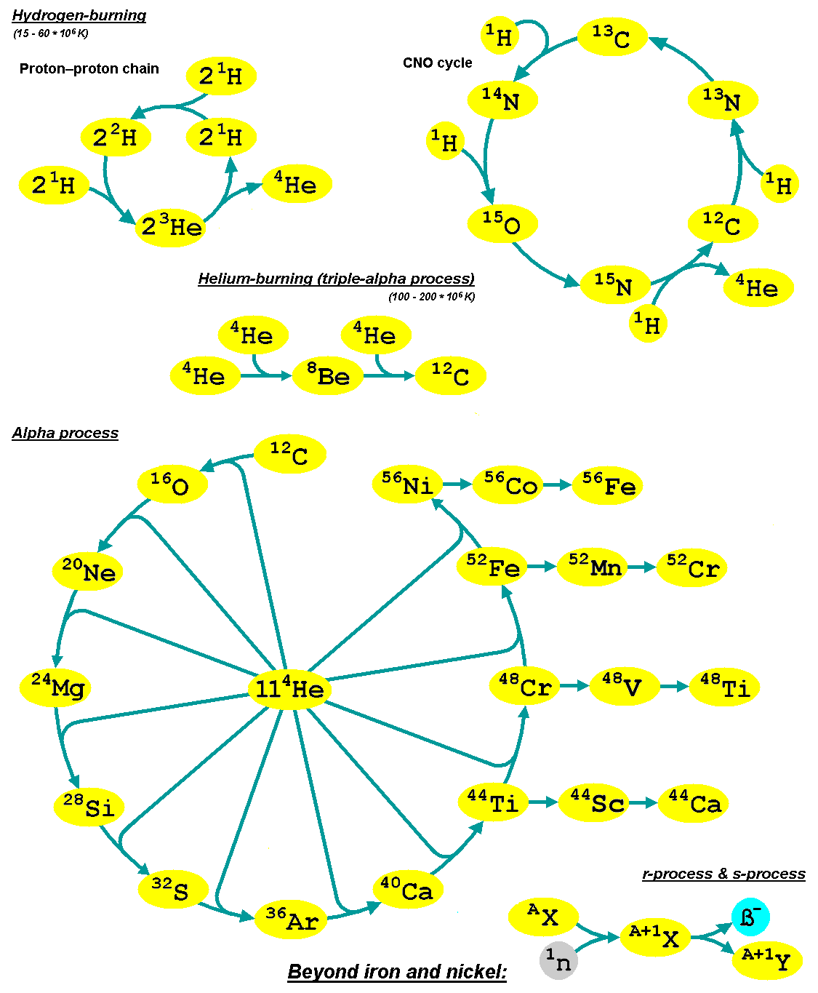
- https://upload.wikimedia.org/wikipedia/commons/4/44/Kernfusionen1_en.png
- 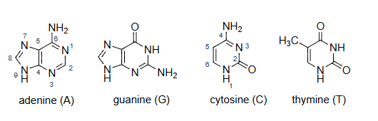
- https://atdbio.com/nucleic-acids-book/Nucleic-acid-structure
  - A = C₅H₅N₅
  - G=C₅H₅N₅O
  - C=C₄H₅N₃O
  - T=C₅H₆N₂O₂
- 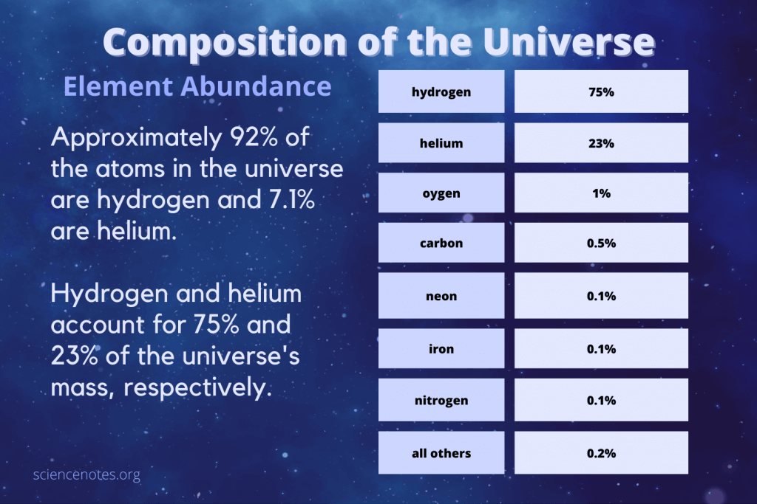
  - Scale for mass
- 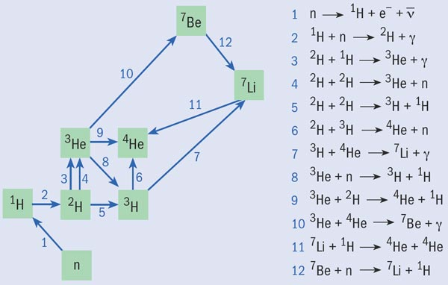
  - https://www.google.com/search?q=nucleosynthesis+in+big+bang
  - “Its two minutes after the big bang…”

